Ministry of Education, Science, Research and Sport of SR
Slovak Centre of Scientific and Technical Information
Gymnázium of Viliam Pauliny-Tóth MARTIN
Slovak Society of Electronics Bratislava

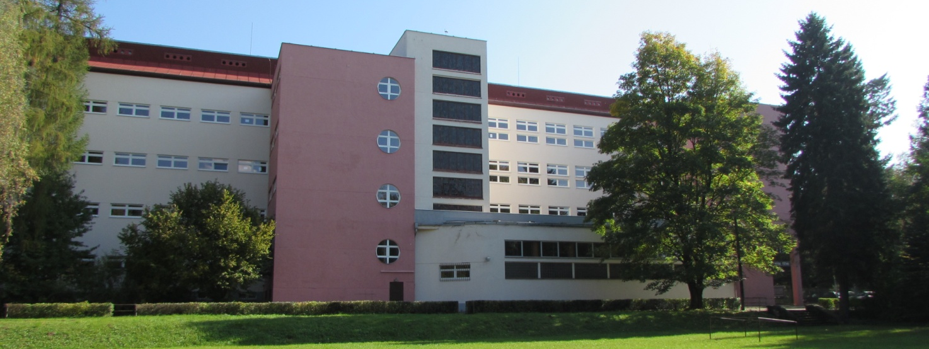
NATIONAL COMPETITION
in building and programing robots
for primary and secondary schools

R o b o C u p 2 0 1 7
M a r t i n

April 6 th – 8 th 2017
E V E N T I N F O R M A T I O N
21th annual contest in building and programming robots
for primary and secondary schools
Contest goals: development of free-time activities, creativity, knowledge, and skills of young generation in the area of construction and programming of automation and cybernetics systems and control of technological processes

Annoucer: Ministry of Education of The Slovak Republic
Slovak Centre of Scientific and Technical Inf.
Local organizer: Gymnazium of Viliam Pauliny-Tóth, Martin
Malá hora 3, 036 01 Martin
Contest organizer: Slovak Society of electronics , Robotika SK
Gymnázium Viliama Paulinyho-Tótha, Martin
Organizing committee: Mgr. Darina Súderová, RNDr.Alica Karkušová, PaedDr. Tomáš Dudík, Mgr. Stanislav Slačka
Head of Contest: Miro Kohút, (0905 521 989)
Head of Jury: Mgr. Pavel Petrovič, PhD. (0915 772 685)
Date: April 6 th – 8 th 2017
Súťažné kategórie: Construction
1. Building robot from a robotic set (participants bring
their own) to solve a specific task
2. Robotic Hand
RoboCup Junior:
- Soccer - Open League with orange ball
- Soccer - Light weight with electronics ball
- Rescue Line
- Rescue Maze
- CoSpace Rescue – only simulated version
- Dance
Participants in all categories can come either from the primary or secondary schools, they will be evaluated separately. The same age limits as in the international competition have to be respected.
In the category Construction, the teams will build, program, and debug/test their robot using their own robot construction set (its type is not limited) so that the robot will satisfy the requirements of the task specified after the contest will start.
The scoring will be announced at the start of the contest and the Jury will take into account the differences of the construction sets used, if needed.
The RoboCup Junior categories will be evaluated in two separate age categories:
• Primary: teams in which all the members have up to 14 years (including; decisive date of birth is June 30th, team with a member born before July 1st is considered as seconday)
• Secondary: teams in which all the members have between 14 to 19 years (including; the same decisive date is applied). Note that including a team member older than 19 years is a violation of the international rules.
Competiton will be run according to international rules (www.robocup.org) with some restrictions/adjustments. The only change is in the duration of robotic Soccer games. These will last 2 x 5 minutes.

Winning teams from Slovakia in the RoboCup categories advance
to the 20th RocoCup World Championship held in Nagoya, Japan
July 27th – July 31st 2017 - www.robocup.org

Preliminary tourament schedule:

Thursday, April 6th 2017

by 12:00 - arrival, on-site registration, accommodation
12:00 - Lunch
13:00 - Opening ceremony
13.30 - Construction, Robotics hand
18.30 - Dinner
19:00 - Construction - Robotic runs
19.30 - social or robotic program

Friday, April 7th 2017 7:00 - Breakfast
8:00 - Soccer, Rescue Line
10:00 - Rescue Maze
13:00 - Lunch
14:00 - Dance, Rescue, Soccer
18:00 - dinner
20.00 - final matches and presentations

Saturday April 7th 2017 7:00 - breakfast
8:00 - award ceremony
10:00 - departure
The time schedule is subject to change and any changes will be announced in advance.

Registration:
Registration link is provided at the contest organizer website www.skse.sk
The registration fee for all categories is 0,- €.
The fee for food and accommodation is 39 € per person, payable by bank transfer to the account in UniCredit Bank, account number: 6601031002 /1111, include the school ZIP code in the payment details. IBAN: SK44 1111 0000 0066 0103 1002, SWIFT (BIC):UNCRSKBX.
Other important information:
Every participant (or their parents or mentors) have to agree with publishing photographic materials, construction details of their models, and programs used in their robots in order to allow other teams to continue and thus foster development of even better designs, programs, sensors, and technologies.
Every team should bring their own robotic construction set for the category construction or their own robot for the RoboCup categories and slippers to school premises .
The number of teams per school is not limited. The number of members in team is not limited. A team may participate in multiple categories, however, they should have enough man-power not to make trouble in the time schedule.
Contest will be held at Gymnazium of Viliam Pauliny-Toth in Martin, Malá
hora 3, 036 01 Martin (www.gymmt.sk). There will be food starting lunch April
6th ending dinner April 7th without breakfasts. There will be also on-site
registration, opening ceremony and awards ceremony.
Accommodation is provided for registered participants in student dormitory arranged as a hostel, Associated school, the Red Army 25, Martin, where will be served the breakfast .
Transportation from accommodation to schoole and back is provided by organizer.
The organizing committee has the right to make modifications in the time schedule as needed. The local organizers will provide the accommodation, and meals in the school canteen, the venue, and the contest arenas for the registered participants.
Registration is open until midnight on March 30, 2017.
The fee includes accommodation and food. The travel expenses have to be covered by the participanting teams themselves.
Shall any material loss be caused by improper behavior of the participants, they will have to be refunded. The organizer does not take the responsibility for the personal items and equipment of the participants.

